

SECP2523
DATABASE (WBL)
SECTION 02

ASSIGNMENT 1

LECTURER:
DR. SEAH CHOON SEN

GROUP MEMBER:
LEE YIN SHEN (A23CS0236)

QUESTION 1
One of the application areas of database systems is e-commerce such as online shopping.
What are the data or information stored in the database system of an online shopping website? Give FOUR (4) of them.

Data | 1. Order  2. Payment  3. Product  4. Customer
Information | 1. Iphone 16  2. Online Banking  3. Casing Iphone 16  4. Address

QUESTION 2
Answer the questions below based on the following relational schema:
SCIENTIST (Sc_ID, Sc_Name, Sc_Phone, Sc_Add) EXPERIMENT (Exp_NO, Ex_Name, Proj_Code) PROJECT (Proj_Code, Proj_Name, Proj_StartDate)
SCIENTIST_EXPERIMENT (Sc_ID, Exp_NO, Date, Time)

- For each table, identify the primary key and foreign key. If a table does not have a primary key or foreign key, write – in the space provided. (4M)
TABLE | PRIMARY KEY | FOREIGN KEY
SCIENTIST | Sc_ID | -
EXPERIMENT | Exp_NO | Proj_Code
PROJECT | Proj_Code | -
SCIENTIST_EXPERIMENT | Time | Sc_ID, Exp_NO

- Does the table exhibit entity integrity? Answer ‘Yes’ or ‘No’ and then explain your answer. (4M)
TABLE | ENTITY INTEGRITY | EXPLANATION
SCIENTIST | Yes | Because it has a primary key.
EXPERIMENT | Yes | Because it has a primary key.
PROJECT | Yes | Because it has a primary key.
SCIENTIST_EXPERIMENT | Yes | Because it has a primary key.

- Does the table exhibit referential integrity? Answer ‘Yes’ or ‘No’ and then explain your answer. (4M)
TABLE | REFERENTIAL INTEGRITY | EXPLANATION
SCIENTIST | No | Because it has no foreign key.
EXPERIMENT | Yes | Because it has a foreign key.
PROJECT | No | Because it has no foreign key.
SCIENTIST_EXPERIMENT | Yes | Because it has a foreign key.

- Draw ERD using Chen notation based on the given relational schema. (4M)

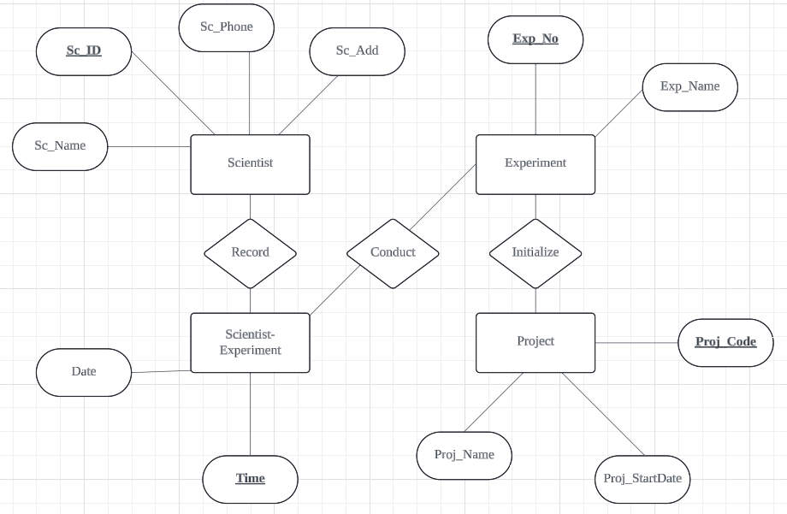

QUESTION 3
Read the following and complete the task listed. Consider the following about Luxury Records:
Here is the information that you gather:
- Luxury has decided to store information about musicians who perform on its albums (as well as other company data) in a database.
- Each musician that records at Luxury has an SSN, a name, an address, and a phone number.
- Poorly paid musicians often share the same address, and no address has more than one phone.
- Each instrument used in songs recorded at Luxury has a unique identification number, a name (e.g guitar, synthesizer, and a flute) and a musical key (e.g., C, B-flat, E-flat).
- Each album recorded on the Luxury label has a unique identification number, a title, a copyright date, a format (e.g., CD or MC) and an album identifier.
- Each song recorded at Luxury has a title and an author.
- Each musician may play several instruments, and a given instrument may be played by several musicians.
- Each song album has a number of songs on it, but no song may appear on more than one album.
- Each song is performed by one or more musicians, and a musician may perform a number of songs.
- Each album has exactly one musician who acts as its producer.
- A musician may produce several albums, of course. Task:
- List each Entity that is identified in Luxury Records System.
- For each entity list the attributes.
- Draw a logical model to represent each entity and the relationships between them.
- Draw an Entity Relationship Diagram (ERD) that captures the entire system.

Ans:

1, 2.
Entity | Attribute
Musician | SSN, name, address, phone number
Instrument | ID number, name, musical key
Album | ID number, title, copyright date, format, album ID
Song | Title, author

3.
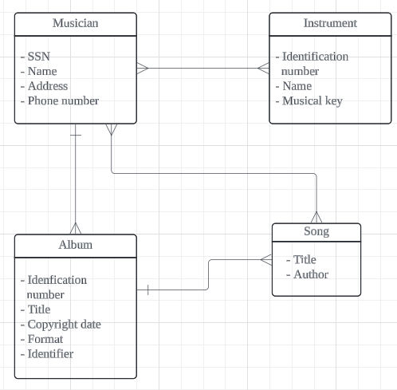

4.
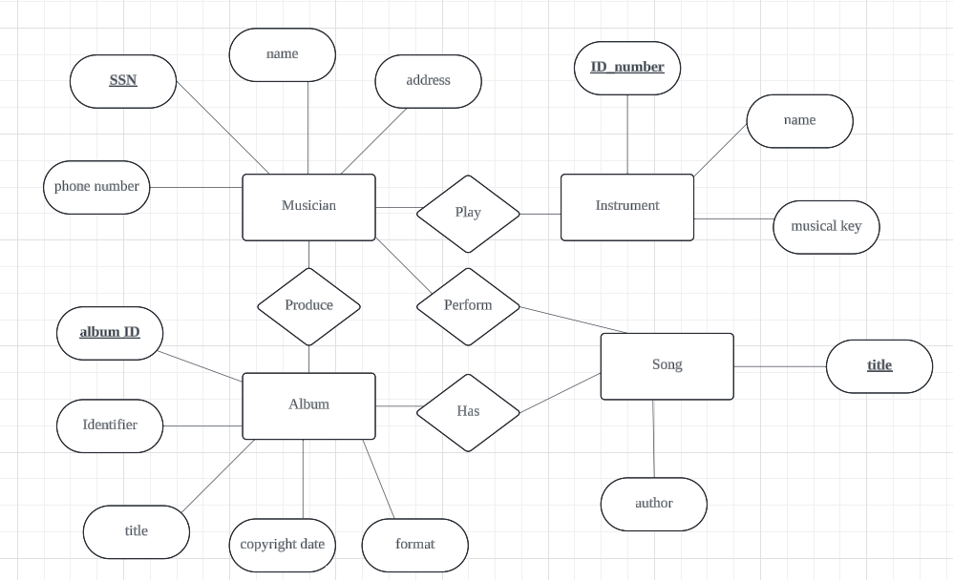

QUESTION 4
Give an example of each of the three types of relationships.
- One-to-many relationship
- A customer can buy many products.

- Many-to-many relationship
- A musician can play many song, a song can be played by many musicians.

- One-to-one relationship
- A student can only take a program.

- Many-to-one relationship
- Multiple songs can have only one producer.

QUESTION 5
CLIENT ( Client_Number, Clent_Name, Street, City, State, Postal_Code, Amount_Paid, Current_Due, Recruiter_Number)
RECRUITER (Recruiter_Number, Last_Name, First_Name, Street, City, State, Postal_Code, Rate, Commission)

- What is the relationship between Recruiter and Client?
- Many to one

- What is the primary key for the Client table and Recruiter table?
- Client_Number
- Recruiter_Number

- Define foreign key? Identify foreign key in the Client table.
- An attribute of an entity which serve for another entity. Recruiter_Number.

QUESTION 6
Draw the Chen & Crow’s Foot notation based on the following statements:
- “A customer can make many payments, but each payment is made by only one customer.”
- “A medical doctor may treat many patients. Some patients may be treated by more than one medical doctor. A patient may have or may not have insurance plan.”

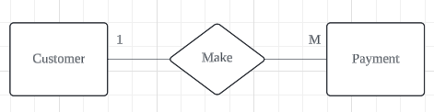
i)

ii)

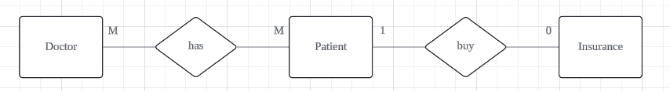

QUESTION 7
Consider the following relations for a database that keeps track of student enrollment in courses and the books adopted for each course:
STUDENT(SSN, Name, Major, Bdate) COURSE(Course#, Cname, Dept) ENROLL(SSN, Course#, Quarter, Grade)
BOOK_ADOPTION(Course#, Quarter, Book_ISBN) TEXT(Book_ISBN, Book_Title, Publisher, Author)
Draw a relational schema diagram specifying the foreign keys for this schema.

